**Future Tenses**

**Will**

 We use [***will***](https://learnenglish.britishcouncil.org/node/10380):

* when we express beliefs about the future:

*It****will be****a nice day tomorrow.  
I think Brazil****will win****the World Cup.  
I'm sure you****will enjoy****the film.*

* to mean ***want to*** or ***be willing to***:

*I hope you****will come****to my party.  
George says he****will help****us.*

* to **make offers and promises** :

*I****'ll****see you tomorrow.  
We****'ll send****you an email.*

* We use the Future Simple tense when there is no plan or decision to do something before we speak. We make the decision spontaneously at the time of speaking. The decision is made at the time of speaking.

Hold on. **I'll g**et a pen.

We **will see** what we can do to help you.

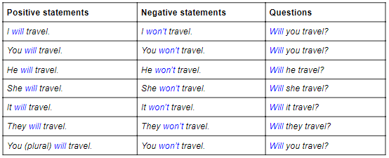

**Shall**

We can use *shall* instead of *will* for future time references with *I* and *we*. However, it is slightly more formal.

E.g. *We shall never forget this beautiful day*.

It is also common to use *shall* in questions to make offers, suggestions or ask for advice.

E.g. *Shall I carry these bags for you?*

*Shall I open the window?*

*What shall I tell Mary about the broken vase?*

**Going to**

We use ***be going to***:

* to talk about **plans or intentions**:

*I****'m going to drive****to work today.  
They****are going to move****to Manchester.*

* to make **predictions** based on **evidence** we can see:

*Be careful!****You are going to fall****.*(= I can see that you might fall.)  
*Look at those black clouds. I think****it's going to rain****.*(= I can see that it will rain.)

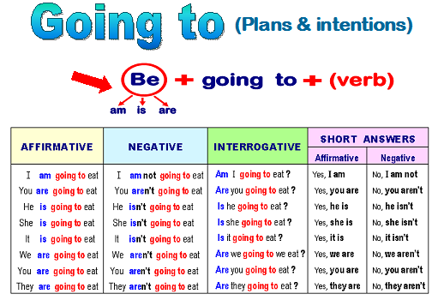

**Present Continuous**

We can use the [**present continuous**](https://learnenglish.britishcouncil.org/node/1401) for **plans or arrangements**:

I***'m playing*** football tomorrow.They ***are coming*** to see us tomorrow.We***'re having*** a party at Christmas.

